Partnership Information
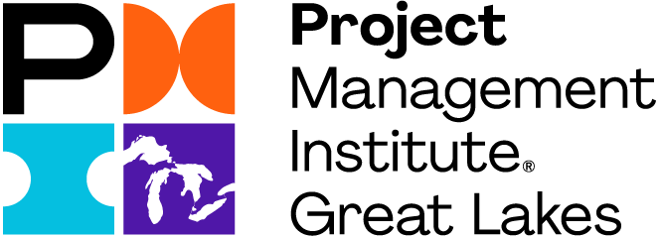
2026 Packet

Prepared for

XXXXXXX

at

YYYYYY(Logo)

Greetings!
Welcome to your Partnership with the Project Management Institute (PMI)’s Great Lakes chapter (PMIGL)! Let me start by saying Thank you for your consideration and potential commitment to partnering with PMIGL in 2026.
PMIGL invites you to partner with us as we continue to promote and enhance project management knowledge, skills, and leadership in Southeast Michigan. PMIGL has been serving its members and stakeholders since 1979 and is the Metro Detroit region’s largest chapter in terms of membership (over 1850) and events offered.
Partnership with PMIGL offers an excellent opportunity for YYYY to showcase products and services to an audience that has a significant say in the business decisions of their organizations. Additionally, PMI members are part of the world’s leading not-for-profit professional membership association for the project, program, and portfolio management profession. PMI delivers value for more than 2.9 million professionals working in nearly every country in the world through global advocacy, collaboration, education, and research.

We would like to introduce our Partnership format, which was created in support of our chapter and to ensure our partners achieve their goals as well. The model for 2026 Partnership is a one-time commitment to partner with you and your organization to promote your involvement with PMIGL for the full program year, at whichever funding level you prefer. Your Partnership will run through December 31, 2026. Additional details about levels and value are available further in this packet.
Your generous support will allow us to continue funding our popular professional development programs including Monthly Lunch and Learn, Quarterly In-person meetings, our new military and community outreach programs, as well as a Symposium, Professional Development Day PDD), and Golf Outing in 2026. This support provides your organization with prominent visibility in the PMIGL community as a key supporter of the project management profession.
Please feel free to contact Srini Pinnamaneni, Srinivas Gogineni, or any volunteer of the Partnership team, for clarification regarding Partnership opportunities available to help YYYY to reach influencers and decision-makers to move your business forward in 2026.

We can’t wait to hear from you!
Srini Pinnamaneni  Vice President  Marketing, Partnership & Publicity  vp.marketing@pmiglc.net | Srinivas Gogineni,  Director  Partnership  director.Partnership@pmiglc.net

CONTENTS
INTRODUCTION 4
2026 Partnership PLANNING CALENDAR 7
Partnership OPPORTUNITIES 8
Exclusive 2026 Opportunity: PMI Global Summit Comes to Detroit 8
ANNUAL SPRING SYMPOSIUM Partnership 9
ANNUAL GOLF OUTING Partnership 9
PROFESSIONAL DEVELOPMENT DAY (PDD) 9
Monthly Lunch and Learn MEETINGS 10
ANNUAL PMI GLOBAL SUMMIT 10
Quarterly In-person MEETINGS 11
HAPPY HOUR/SOCIAL NETWORKING 11
NEWSLETTER ADVERTISING 11
CHAPTER SUSTAINED Partnership 12
EVENT Partnership 18
OTHER Partnership OPPORTUNITIES 20
HOW TO RESERVE YOUR Partnership OPPORTUNITY? 24
Partnership OPPORTUNITY TABLE FOR REFERENCE 26

INTRODUCTION

Vision: Provide dynamic opportunities for growth.
Mission: Deliver inspirational education, networking, professional service, and volunteer opportunities.
Change is inevitable. Organizations constantly wrestle with changes in markets, customer needs, technology, and other forces. Change also breeds projects designed to fulfill the need to innovate and adapt to change. Bringing these projects in on time, within budget, and meeting requirements equates to an effective use of capital. This is the essence of project management and the creed of professional project managers everywhere.
PMIGL provides its 1850+ members with:
- Monthly education and networking meetings
- Certification
- Education and training
- Publications
- Professional development
- Outreach program for academic, military, community academia, and businesses
- Opportunities to earn professional development units for maintaining credentials.
- Opportunities to give back and share the passion.

Project managers drive the changes and innovation that strengthens organizations. We invite YYYY to join those who currently partner with PMIGL and take a prominent position in the community as a key supporter of the project management profession.
How can you deliver your ads to prospective customers at the same time? How can you make sure your ad is targeting people who want to buy? Newsletter advertising is a proven and simple method that ensures that YYYY’s logo will be seen by people interested in what you have to offer. The same holds true for partnering events held for your targeted audience.

PMIGL communicates its message to members and other stakeholders through its website, monthly newsletters, Lunch & Learns, quarterly meetings, email blasts, and various events throughout the year. Advertising and partnering with PMIGL provides a cost-effective solution to reaching potential customers in the project management profession. Our members and stakeholders fit into one of the three groups – consumers, influencers, or buyers of the services and products related to project management.

PMIGL offers the following means of advertising:
Events Partnership (i.e., Annual Spring Symposium, Professional Development Day (PDD), Golf Outing, workshops, monthly & quarterly meetings, happy hour and mix & mingle events)
- Monthly Baseline News (12 issues) and weekly emails and reminders
- Monthly & quarterly meeting partnership with slide deck advertising
- Web advertising

Chapter Sustained Partnership
Chapter Sustained Partnership is designed to allow companies to build a presence within the project management community and experience maximum exposure through various PMIGL opportunities. Partnership at the chapter sustained level features multiple event Partnerships and combined advertising packages. Benefits included in the Chapter Sustained Partnership are at a discounted rate when compared to individual Partnership offerings.

Virtual Events
We have Partnership events, which will be available in physical and virtual formats in 2026. Details of virtual and in-person events are available in the Planning Calendar.

2026 Partnership PLANNING CALENDAR
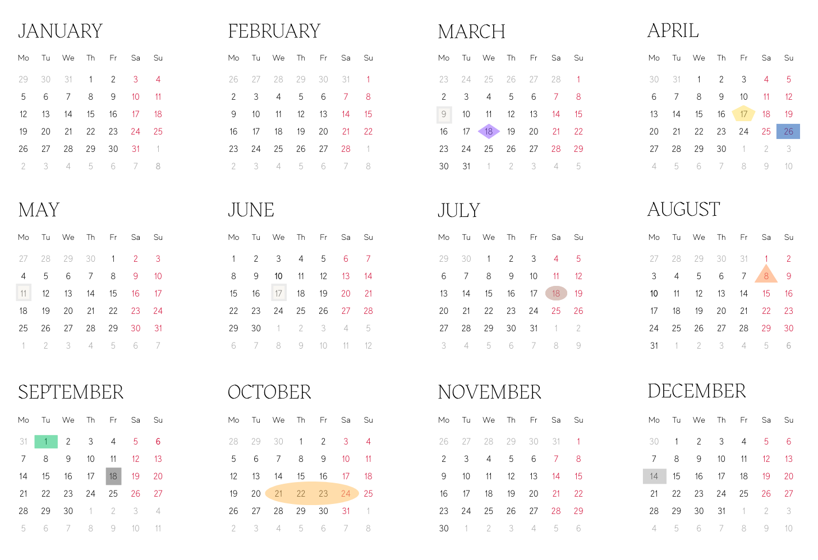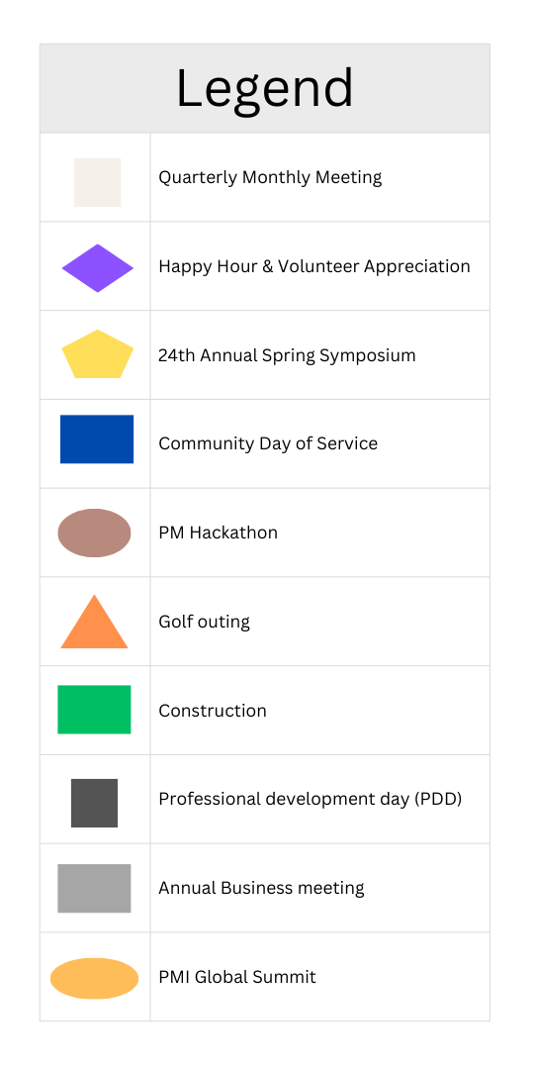

PARTNERSHIP OPPORTUNITIES

Exclusive 2026 Opportunity: PMI Global Summit (GS) comes to Detroit.
This is a once-in-a-generation opportunity for Metro Detroit partners.
The PMI Global Summit 2026 (October 21-24, 2026) is the Project Management Institute's premier annual flagship event, bringing together 5,000+ project management professionals from across the globe for four (4) days of immersive learning, networking, and thought leadership. This year's Summit will explore cutting-edge trends transforming our profession including artificial intelligence, sustainability in project delivery, and adaptive leadership while showcasing real-world project impact from organizations worldwide.
And it's happening right here in Detroit.
As the local PMI chapter hosting this international event, PMIGL is uniquely positioned to connect our partners with both our 2,000+ local members AND thousands of visiting project management professionals, executives, and decision-makers from Fortune 500 companies, government agencies, and leading organizations worldwide.
Your PMIGL Partnership unlocks Summit access. Based on your chapter Partnership tier, complimentary Global Summit passes are included:
- Diamond Partners: 2 complimentary Summit passes (valued at $3,600)
- Platinum Partners: 1 complimentary Summit passes (valued at $1,800)
- Gold Partners: Discounted (up to 25%) Summit registration for up to 2 attendees
This dual exposure—sustained visibility throughout 2026 with PMIGL's local community PLUS concentrated access to an international audience during Summit week—creates unparalleled value for organizations seeking to:
- Recruit top project management talent.
- Showcase products and services to decision-makers.
- Build brand recognition in both local and global PM communities.
- Demonstrate thought leadership on the international stage.
Don't miss this opportunity to maximize your investment while the world's PM community is watching Detroit.

ANNUAL SPRING SYMPOSIUM PARTNERSHIP
PMIGL’s Annual Spring Symposium is an educational and networking forum designed to facilitate continued professional development using the latest tools, techniques, and advancements made in the field of Project Management. The Symposium is one of the flagships events the chapter has offered for 20 years. As we continue to grow and succeed, it’s important to know that companies like yours play a major role in what we do!

In the previous years, our Annual Symposium draws over 300 attendees from PMIGL and other PMI chapters in Michigan, Ohio, and Canada. Many of these individuals hold influential positions within various local and national companies such as DTE Energy, Ford, General Motors, Accenture, Siemens, Ascension Health, Corewell Health and many others.

The 24th Annual Symposium offers an excellent opportunity for YYYY to showcase your products and services to an audience that has significant influence in the business decisions of their organizations. This year’s Symposium will be held in person on Friday, April 17. The theme this year will be "Implementing AI in a Project Management World".

The Symposium Partnership openings will be filled on a first-come, first-served basis to the extent of available space.

ANNUAL GOLF OUTING PARTNERSHIP
Another way to promote your YYYY’s products or services and enjoy a day outdoors is to partner with the PMIGL Golf Outing. This event is designed to be both a fun day outdoors and a professional networking event. An 18-hole round of golf, lunch mid-way, and dinner are all part of the event. Partner applications are filled on a first-come, first-served basis to the extent of available space — which is targeted at 20 partners in total.

Additional green fees and/or meals per partner representative, if desired, are available upon request for an additional discounted fee. Partners are encouraged to provide their corporate items for prizes. Prizes will be handed out at the event dinner by a PMIGL representative.

PROFESSIONAL DEVELOPMENT DAY (PDD)
PMIGL member feedback has been extremely positive for the PDD event. It once again brings together a group of project management professionals to interact with one another on various topics.

PDD is scheduled to be held this year in the fall on September 18th. This event will feature the same high-quality speakers, top-notch venue, and attractive PDU level as our Symposium. It provides attendees with the opportunity to learn new skills and network. It is also a great opportunity for partners to meet with those who are in the project management profession.

As a PDD partner, you will be displaying your YYYY name, products, and services in front of the area’s premier current and future business leaders. Our membership consists of a wide array of project management professionals and executives that represent a broad base of
industries. Partner applications are filled on a first-come, first-served basis to the extent of available space. Partners are encouraged to provide their corporate items for prizes which will be handed out during the event at key times by a PMIGL representative.

Monthly Lunch and Learn MEETINGS
The PMIGL Monthly Lunch and Learn meetings take place on the second Monday of each month from 5 to 8 p.m. for in-person events and 6 to 7 p.m. for virtual events. The agenda consists of networking time, dinner, and presentations from key professionals in the project management field. These meetings intend to provide an atmosphere for learning and meeting among colleagues with similar interests. Professional Development Units (PDUs) are earned for the attendance of the event.

Partners will have the opportunity to meet with attendees and highlight their contributions to the field of project management professionals. Partner applications are filled on a first-come, first-served basis to the extent of available space. Partners are encouraged to provide their corporate items for prizes. Prizes will be handed out during the event at key times by a PMIGL representative.

Quarterly In-person MEETINGS
This is a new addition to the value for our members and partners. PMIGL plans to organize In-person meetings every quarter during 2026. Like dinner meetings, the agenda will consist of networking time, In-person, and presentations from key professionals in the project management field. Participants are asked to share their experiences and opinions followed by practical tips from the guest speaker. Professional Development Units (PDUs) are earned for the attendance of the event.

HAPPY HOUR/SOCIAL NETWORKING
Another way to promote your YYYY’s products or services is to partner with the PMIGL Happy Hour. This is a social networking event that is scheduled to happen three times in 2026. Partner applications are filled on a first-come, first-served basis to the extent of available space.

COMMUNITY DAY OF SERVICE
You can help local nonprofits address their most critical projects and initiatives by donating your time and project management expertise while earning PDUs!

Project Management for Change is a 501(c)(3) nonprofit organization whose mission is to unleash the boundless potential of the Project Management discipline to empower and transform communities around the world. Join us in changing the world, one project at a time! Partner applications are filled on a first-come basis. Visit www.pm4change.org today for more information.

NEWSLETTER ADVERTISING
PMIGL currently publishes an electronic newsletter titled “Baseline News” each month. It is published for the benefit of over 2,000-chapter members and stakeholders. It highlights educational opportunities and events that will enhance our members’ professional development. It is posted online and available for download from the PMIGL website (https://pmiglc.org/pmiglc-baseline-newsletter/).

partners can coordinate with PMIGL to advertise in the Baseline News each month with size options and formatting assistance from a PMIGL representative.

WEBSITE ADVERTISEMENT
PMIGL provides prime chapter website homepage space to exhibit logos of our advertising partners. In addition, there are event-specific website pages that highlight partner products, goods, and services.

Website advertisements without hyperlinks are also available upon request.

CHAPTER SUSTAINED PARTNERSHIP
Partner Level | Partnership Event | Benefits to Partners
Diamond  $10,000 | Symposium | - 8 complimentary admissions to the Symposium. Additional admissions may be purchased up to a maximum of 4 people at a discounted rate.  - Logo and name on the Symposium brochure.  - Event website advertisement for the event month. Content limited to the following:  - Corporate logo and name of the partner  - Link to the corporate website  - Short description of services and products with contact information including name, phone, and email address.
Diamond  $10,000 | Golf Outing | - 4 complimentary admissions to the Golf Outing (includes green fees, golf cart and meals).  - partner name recognition on the Golf Outing website for 3 months before the event.  - 2 Golf hole Partnership advertising provided to you by PMIGL. PMIGL will print and display your logo, if provided before the registration deadline, with your partner agreement.
Diamond  $10,000 | Professional Development Day | - 5 complimentary admissions to PDD and meals. Additional admissions may be purchased for up to a maximum of 4 people at a discounted rate.  - One (1) 8 ft table, tablecloth, and chairs.  - Logo and name on the Event brochure.  - Event website advertisement for the event month. Content is limited to the following:  - Corporate logo and name of the partner  - Link to the corporate website  - Short description of services and products with contact information including name, phone, and email address.  - Corporate logo on the Symposium participant take-away.  - Podium address (2 minutes) – lunch.  - Monthly Lunch and Learn meeting slide deck advertisement for 3 months starting February through April (2 months before the event and the month of the event). Advertisement will include the following:  - Corporate logo  - Name of partner  - Level of Partnership
Diamond  $10,000 | Dinner  and  In-person Meetings | - 2 complimentary tickets for 6 meetings.  - 6’ skirted display at the meeting location.  - partner introduction  - partner slide deck presentation.  - Advertisement will include the following:  - Corporate logo  - Name of the partner  - Level of Partnership
Diamond  $10,000 | Baseline News | - 1/2 Page advertising for 12 months.
Diamond  $10,000 | Website Ads | - Advertising with links to the corporate site.
Diamond  $10,000 | PMI Global | - 2 complimentary Summit passes (valued at $3,600)
Diamond  $10,000 | Happy Hour | - 2 complimentary tickets for 4 events.

Partner Level | Partnership Event | Benefits to Partners
Platinum  $6000 | Symposium | - 5 complimentary admissions to the Symposium. Additional admissions may be purchased for up to a maximum of 4 people at a discounted rate.  - Logo and name on the Symposium brochure.  - Event website advertisement for the event month. Content is limited to the following:  - Corporate logo and name of the partner  - Link to the corporate website  - Short description of services and products with contact information including name, phone, and email address.
Platinum  $6000 | Golf Outing | - 2 complimentary admissions to the Golf Outing (includes green fees, golf cart, and meals).  - Partner name recognition on the Golf Outing website for 3 months before the event.  - Golf hole Partnership advertising provided to you by PMIGL. PMIGL will print and display your logo, if provided before the registration deadline, with your partner agreement.
Platinum  $6000 | Professional Development Day | - 2 complimentary admissions to PDD and meals. Additional admissions may be purchased for up to a maximum of 4 people at a discounted rate.  - One (1) 8 ft table, tablecloth, and chairs.  - Logo and name on the Event brochure.  - Event website advertisement for the event month. Content is limited to the following:  - Corporate logo and name of the partner  - Link to the corporate website  - Short description of services and products with contact information including name, phone, and email address.  - Corporate logo on the Symposium participant take-away.  - Podium address (2 minutes) – lunch.  - Monthly Lunch and Learn meeting slide deck advertisement for 3 months starting February through April (2 months before the event and the month of the event). Advertisement will include the following:  - Corporate logo  - Name of partner  - Level of Partnership
Platinum  $6000 | Dinner  and  In-person Meetings | - 2 complimentary tickets for 6 meetings.  - 6’ skirted display at the meeting location.  - Partner introduction  - Partner slide deck presentation.  - Advertisement will include the following:  - Corporate logo  - Name of the partner  - Level of Partnership
Platinum  $6000 | Baseline News | - 1/2 Page advertising for 12 months.
Platinum  $6000 | Website Ads | - Advertising with links to the corporate site.
Platinum  $6000 | Happy Hour | - 2 complimentary tickets for 4 events.
Platinum  $6000 | PMI Global | - 1 complimentary Summit pass (valued at $1,800)

Gold  $4000 | Symposium | - 3 Complimentary admissions to the Symposium. Additional admissions may be purchased for up to a maximum of 4 people at a discounted rate.  - Logo and name on the Symposium brochure.  - Event website advertisement for the event month. Content is limited to the following:  - Corporate logo and name of the partner  - Link to the corporate website  - Short description of services and products with contact information including name, phone, and email address.
Gold  $4000 | Golf Outing | - 2 complimentary admissions to the Golf Outing (includes green fees, golf cart, and meals).  - Partner name recognition on the Golf Outing website for the event.  - Golf hold Partnership advertising provided to you by PMIGL. PMI will print and display your logo, if provided before the registration deadline, with your partner agreement.
Gold  $4000 | Professional Development Day | - 2 complimentary admissions to PDD and meals. Additional admissions may be purchased up to a maximum of 4 people at a discounted rate.  - One (1) 8 ft table, tablecloth, and chairs.  - Logo and name on the PDD brochure.  - Event website advertisement for the event month. Content is limited to the following:  - Corporate logo and name of the partner  - Link to the corporate website  - Short description of services and products with contact information including name, phone, and email address  - Corporate logo on the PDD participant take-away.  - Podium address (2 minutes) – In-person.  - Monthly Lunch and Learn meeting slide deck advertisement for 3 months starting February through April. Advertisement will include the following:  - Corporate logo  - Name of partner  - Level of Partnership
Gold  $4000 | Dinner  and  In-person Meetings | - 2 Complimentary tickets for 6 meetings.  - 6’ skirted display at the meeting location.  - Partner introduction  - Partner slide deck presentation.  - Advertisement will include the following:  - Corporate logo  - Name of the partner  Level of Partnership
Gold  $4000 | Baseline News | - 1/2 Page advertising for 6 months.
Gold  $4000 | Happy Hour | - 2 complimentary tickets for 2 events.

Silver  $2500 | Symposium | - 2 complimentary admissions to the Symposium. Additional admissions may be purchased for up to a maximum of 4 people at a discounted rate.  - Logo and name on the Symposium brochure.  - Event brochures insert.
Silver  $2500 | Golf Outing | - 2 complimentary admissions to the Golf Outing (includes green fees, golf cart, and meals).
Silver  $2500 | Professional Development Day | - 2 complimentary admissions to PDD and meals.  - One (1) 8 ft table, tablecloth, and chairs.  - Logo and name on the PDD brochure.  - Corporate logo on the PDD participant take-away.  - Monthly Lunch and Learn meeting slide deck advertisement for 3 months starting February through April. Advertisement will include the following:  - Corporate logo  - Name of partner  - Level of Partnership
Silver  $2500 | Dinner  and  In-person Meetings | - 2 complimentary tickets for 3 meetings.  - 6’ skirted display at the meeting location.  - Partner introduction  - Partner slide deck presentation.  - Advertisement will include the following:  - Corporate logo  - Name of partner  - Level of Partnership
Silver  $2500 | Baseline News | - 1/4 Page advertising for 6 months.
Silver  $2500 | Happy Hour | - 2 complimentary tickets for 1 event.

Copper  $1250 | Symposium | - 1 complimentary admission to the Symposium. Additional admissions may be purchased for up to a maximum of 4 people at a discounted rate.
 | Professional Development Day | - 1 complimentary admission with meals.
 | Baseline News | - Business card size advertisement – 3 months.
All partners may provide items for swags at all in-person events. Tables at events are 6’ or 8’, depending on space availability in the event venue. All virtual events will be hosted in webinar format, except the Symposium which will have partner rooms with audiovisual/chat facility in a virtual exhibition platform.

EVENT PARTNERSHIP
Partner Level | Partnership Event | Benefits to Partners
Not for Profit (NFP)  $300 | Symposium | - 1 complimentary admission to the Symposium.
Exhibitor  $1,500 | Symposium | - 2 complimentary admissions to the Symposium.  - Partner room within audiovisual showcase and chat facility in virtual exhibition platform.  - Logo and name on the Symposium brochure.
Event  $2,500 | Symposium | - 3 complimentary admissions to the Symposium.  - Partner room within audiovisual showcase and chat facility in virtual exhibition platform.  - Logo and name on the Symposium brochure.  - Event website advertisement for the event month. Content is limited to the following:  - Corporate logo and name of the partner  - Link to the corporate website  - Short description of services and products. Contact information including name, phone, and email address.  - Dinner and In-person meeting slide deck advertisement for 3 months starting February through April (2 months before the event and the month of the event). Advertisement will include the following:  - Corporate logo  - Name of partner  - Level of Partnership
Premier  $3,500 | Symposium | - 4 complimentary admissions to the Symposium. Additional admissions may be purchased for up to a maximum of 4 people at a discounted rate.  - Partner room within audiovisual showcase and chat facility in virtual exhibition platform.  - Logo and name on the Symposium brochure.  - Event Website Advertisement for the event month. Content limited to the following:  - Corporate logo and name of the partner  - Link to the corporate website  - Short description of services and products with contact information including name, phone, and email address  - Dinner and In-person meeting slide deck advertisement for 3 months starting February through April (2 months before the event and the month of the event). Advertisement will include the following:  - Corporate logo  - Name of partner  - Level of Partnership
Hole  $250 | Golf Outing | - 2 complimentary admissions to the Golf Outing (includes green fees, golf cart, and meals).
Exhibitor  $400 | Golf Outing | - 2 complimentary admissions to the Golf outing (includes green fees, golf cart, and meals).  - Golf hole Partnership advertising provided to you by PMIGL. PMIGL will print and display your logo, if provided before the registration deadline, with your partner agreement.
Event  $600 | Golf Outing | - 4 complimentary admissions to the Golf Outing (includes green fees, golf cart, and meals)  - partner name recognition on the Golf Outing website.  - Golf hole Partnership advertising provided to you by PMIGL. PMIGL will print and display your logo, if provided before the registration deadline, with your Partner agreement.  - Event participants insert.
Not for Profit (NFP)  $250 | Professional Development Day | - 1 complimentary admission to the PDD and meals ($350 value).  - One (1) 8 ft table, tablecloth, and chairs.
Exhibitor  $1000 | Professional Development Day | - 2 complimentary admissions to the Symposium and meals ($350 value). Company attendees are invited to attend the break-out sessions. Additional admissions may be purchased for up to a maximum of 4 people at a discounted rate.  - One (1) 8 ft table, tablecloth, and chairs.  - Logo and name on the PDD brochure.  - Corporate logo on the PDD participant take-away.  - Podium address (2 minutes) – In-person.  - Monthly Lunch and Learn meeting slide deck advertisement for 3 months starting February through April. Advertisement will include the following:  - Corporate logo  - Name of partner  - Level of Partnership
Event  $1,500 | Professional Development Day | - 2 Complimentary admissions to the Symposium and meals ($350 value) Company attendees are invited to attend the break-out sessions. Additional admissions may be purchased for up to a maximum of 4 people at a discounted rate.  - One (1) 8 ft table, tablecloth, and chairs  - Logo and name on the Event brochure  - Corporate logo on the PDD participant take-away.  - Podium address (2 minutes) - In-person  - Monthly Lunch and Learn Meeting Slide Deck Advertisement for 3 months starting February through April. Advertisement will include the following:  - Corporate logo  - Name of partner  - Level of Partnership
Event  $400 | Dinner  and  In-person Meetings and Happy Hour | - 2 complimentary tickets.  - 6’ skirted display at the meeting location.  - Partner introduction  - Partner slide deck presentation

OTHER PARTNERSHIP OPPORTUNITIES
partner Level | Partnership Event
Standard - $125.00 | Website Ads
With Links - $150.00 | Website Ads
Full Page - $350.00 | Baseline News – layout below
Half Page - $175.00 | Baseline News – layout below
Quarter Page - $100.00 | Baseline News – layout below
Business Card - $30.00 | Baseline News – layout below

1/2 page
7.5 w x 5 h
no bleeds
crop marks are preferred but not mandatory
1/4 page  3.75 w x 5 h  no bleeds  crop marks are preferred but not mandatory | business card size  3.75 w x 2 h  no bleeds  crop marks are preferred but not mandatory
Ads:
CMYK color space
Files: PDF’s print (PDF/ X 1a), eps (vector), or high-res jpg
All fonts must be outlined or included.
No transparencies
LOGOS: CMYK color space - EPS (vector) or High-res jpg
Bleed is available for full-page ads only.
FULL PAGE with bleed 8.75 x11.25 or 7.5 x 10 with crop marks

PARTNERSHIP INFORMATION AND CONTACT FORM

Instructions: Save this form to your computer and complete all sections electronically. Upon receipt of payment,
PMIGL will send you a confirmation.
NAME OF CONTACT PERSON
ADDRESS
CITY
EMAIL
NAME OF COMPANY / ORGANIZATION
TITLE OF CONTACT PERSON
STATE
ZIP
PHONE
WEB ADDRESS
CHAPTER PARTNERSHIP LEVEL

Please indicate your Partnership commitment
 | Diamond Partner | $10,000.00 |  |  | PDD Exhibitor | $1,000.00
 | Platinum Partner | $6,000.00 |  |  | PDD Event | $1,500.00
 | Gold Partner | $4,000.00 |  |  | Happy Hour | $300.00
 | Silver Partner | $2,500.00 |  |  | In-person Meeting | $350.00
 | Copper Partner | $ 1,250.00 |  |  | Dinner Meeting | $400.00
 | Symposium NFP | $ 300.00 |  |  | Baseline News Full Page | $350.00/Month
 | Symposium Exhibitor | $ 1,500.00 |  |  | Baseline News ½ Page | $175.00/Month
 | Symposium Event | $ 2,500.00 |  |  | Baseline News ¼ Page | $100.00/Month
 | Symposium Premier | $3,500.00 |  |  | Baseline Business Card | $30.00/Month
 | Golf Outing Hole | $250.00 |  |  | Website Ad - Standard | $125.00/Month
 | Golf Outing Exhibitor | $400.00 |  |  | Website Ad with Link | $150.00/Month
 | Golf Outing Event | $600.00 |  |  | PDD NFP | $ 250

Partnership FEE $
TOTAL ENCLOSED $

PAYMENT OPTIONS

Please charge our credit card. VISA MasterCard Discover American Express

We have enclosed a check (payable to PMIGL). Send to PMIGL, PO Box 771, Novi, MI 48376

We are submitting a purchase order and will pay the invoice within 30 days of its receipt.

NAME ON CARD
CARD NUMBER
AUTHORIZED SIGNATURE
EXP DATE
SEC CODE

SIGNATURE
Acceptance of this application by PMIGL constitutes a contract.

NOTE: Returning this document to the PMIGL with your name in the signature block constitutes an officially signed agreement.

SIGNATURE | DATE

Logo visibility
Your company’s logo will be published in marketing and attendee materials based on the Partnership level purchased, as indicated above. Please email your company’s logo to the director.Partnership@PMIGL.net.

HOW TO RESERVE YOUR PARTNERSHIP OPPORTUNITY?

Simple and easy three-step process to reserve your spot:
- Complete the Partner Agreement Form.
- Email completed agreement forms to director.Partnership@PMIGL.net along with the information required for marketing and publicity campaigns. An event invoice can be provided for the Partnership package upon request.
- If paying by check, send a check made payable to PMIGL to the following address:
PMIGL, PO Box 771, Novi, MI 48376.

Upon receipt of your completed form(s), a PMIGL Marketing team member will contact you and confirm your registration. If all Partnership slots are filled by the time we receive your completed agreement form, then your payment will be refunded to you.

PAYMENT TERMS
All Partnership openings will be filled on a first-come, first-served basis to the extent of available space. Payment is due at the time of agreement unless other arrangements have been agreed to with PMIGL. For event-specific Partnerships, a minimum of 50% of the balance is due 60 days before the event date with the remaining balance paid in full 30 days before the event date.

LIABILITIES
PMIGL assumes no liability and will be held harmless for any liability posed by the content of speaker presentations and partners' display materials. This includes intellectual property rights infringement or other claims against the speaker, presentation content, partner, or display materials.

PMIGL claims no duty to review the content of any advertisement, and the advertiser always remains solely responsible for any content of the advertisement.

- PMIGL reserves the right to change its advertising rates and policy at any time without notice.
- PMIGL assumes no liability and will be held harmless for any liability posed by the content of speaker presentations and Partner display materials. This includes intellectual property rights infringement or other claims against the speaker, presentation content, Partner or display materials.

CANCELLATION POLICY
PMIGL reserves the right in the unlikely event it is required to cancel an event and/or the speaker’s or partner’s participation at any time by notifying the speaker or partner in writing as soon as possible. If notification is made at least 4 weeks before the scheduled event, no payment of expense reimbursements will be made by PMIGL other than Partnership package fees. If cancellation notification is not made at least 2 weeks in advance of the scheduled event, additional reasonable and customary, non-refundable expenses, such as airfare ticket transfer fees, incurred by the speaker or partner will be paid by PMIGL.

INFORMED PHOTOGRAPHIC, AUDIO, AND VIDEO RECORDING CONSENT & RELEASE AGREEMENT
PMIGL may photograph or otherwise record the image and/or voice of the partner or any partner representative at any event. The intent of photography and recording by PMIGL includes, but is not limited to, incorporation into post-event publicity and archiving for members, participants, and other purposes. Therefore, I permit PMIGL, at its discretion, the royalty-free use of these photographs and/or recordings at any time during or after the event.

PMIGL shall not record a speaker’s presentation in its entirety. Speakers at PMIGL events may photograph or otherwise record their presentations and thereby assume all risks associated with that activity. PMIGL shall not be involved or liable whatsoever in that activity.

PRIVACY
PMIGL will never allow its members’ information, such as email addresses, or member ID, without member consent, to be used for any direct marketing or solicitation purposes.

RESTRICTIONS
The following types of advertisements on any medium related to PMIGL are unacceptable, including any URL submitted by an advertiser that may forward the visitor to an external website serving unacceptable content:
- Advertisements for alcohol or tobacco.
- Advertisements for weapons, firearms, ammunition, and fireworks.
- Gambling and lottery advertisements.
- Advertisements for pornography and related materials and services.
- Political and religious advertisements.
- Advertisements that claim to offer a “miracle” cure or method.
- Advertisements that make unsubstantiated health claims for the products advertised.
- Advertisements directed at children.
- Advertisements that are in direct conflict with specific dates of other, already planned PMIGL events.
- Targeted e-blasts that are specific to only one outside group to PMIGL membership.
- No advertising shall be permitted which may injure the good names and reputations of PMI Global or PMIGL.

ACCEPTANCE
All advertisements submitted are subject to the acceptance and approval of PMIGL. Advertisements that are deceptive or misleading (by either statement or omission), make unsupported claims, are detrimental to the public interest, or are otherwise incompatible with the character of PMIGL and its publications will not be accepted.
- Advertisements that PMIGL considers undermining the professionalism of the project management profession and/ or PMIGL also will not be accepted.
- PMIGL, in its sole discretion, reserves the right to decline to accept any proposed advertising and this right shall not be deemed to be waived by prior acceptance or actual use of any advertising matter. PMIGL will consider the overall impression or tone of the advertisement and its impact on the audience for this advertisement in determining whether such an advertisement will be accepted.
- PMIGL may include the word “advertisement” or otherwise add or delete text to or from advertisements that, in PMIGL’s opinion, may resemble editorial matter.
- Publishing or acceptance of an advertisement is neither a guarantee nor endorsement of the Advertiser’s product or service.

INDEMNIFICATION
In consideration for PMIGL’s agreeing to publish an advertisement, advertisers agree to the following:
- Advertisers are fully authorized and licensed to use all intellectual property contained in the advertisement and the use of the name of any individual or entity in a testimonial or other matter is authorized, not libelous, and does not constitute an invasion of privacy.
- Advertisers will defend, indemnify, and hold PMIGL harmless from and against any loss, expense or other liability resulting from claims or suits for libel, slander, violation of rights of privacy or publicity, plagiarism, copyright or trademark infringement, and any other claims or suits that may arise out of the publication of such advertisements.

PARTNERSHIP OPPORTUNITY TABLE FOR REFERENCE

